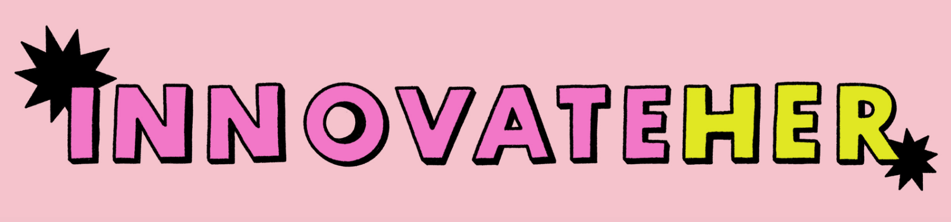
InnovateHer 2026 Application Form
Please note that the deadline to apply to this programme is 10am, Monday 1st December 2025.
Applications should be returned via email to su.enterprise@qub.ac.uk
Name:
Student number:
Degree:
Expected year of graduation:
QUB Email address:
How did you hear about us?

The dates you are required to be available are outlined below. Successful applicants must be able to attend all events.
January 14th 13:00 – 15:00 | Session 1  Students’ Union
February 4th 13:00 – 15:00 | Session 2  Students’ Union
February 19th-20th (Overnight) | Residential  The Rabbit Hotel  (Return transport arranged from SU)
March 5th 12:00 – 19:00 | Final Pitches & Graduation  Baker McKenzie Offices

Are you able to attend all the above events? ☐Y ☐N

Why are you interested in taking part in InnovateHer? (Max. 300 words)

What do you hope to achieve by participating in the programme?
(Max. 300 words)

What is your sweatshirt size?

☐XS ☐ S ☐M ☐ L ☐ XL ☐ XXL

Do you have any dietary requirements? If yes, please indicate below:
☐Yes ☐No

Have you previously applied for InnovateHer? If yes, what year?
☐Yes ☐No

Would you like to receive information about other business events, programmes and opportunities through our Enterprise newsletter?

☐Yes ☐No

Terms & Conditions
The competition is open to all Queen’s University Belfast students identifying as female.
The closing date for applications is 10am, Monday 1st December 2025. Applicants will be notified of the outcome of their application via the e-mail address collected on the application form no later than Monday 8th December. The programme will conclude with a Graduation Event with drinks & nibbles, guest speakers and awards on Thursday 5th March 2026.
Furthermore, as a participant of InnovateHer you will receive a Future Ready Award - an amazing addition to your degree (and your CV!)
View more information here.

